Chapter 12, Problem 74.

Predict the wattmeter readings for the circuit in Fig. 12.75.

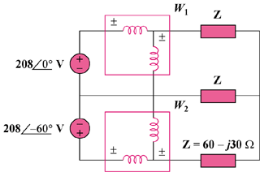

Figure 12.75
For Prob. 12.74.

